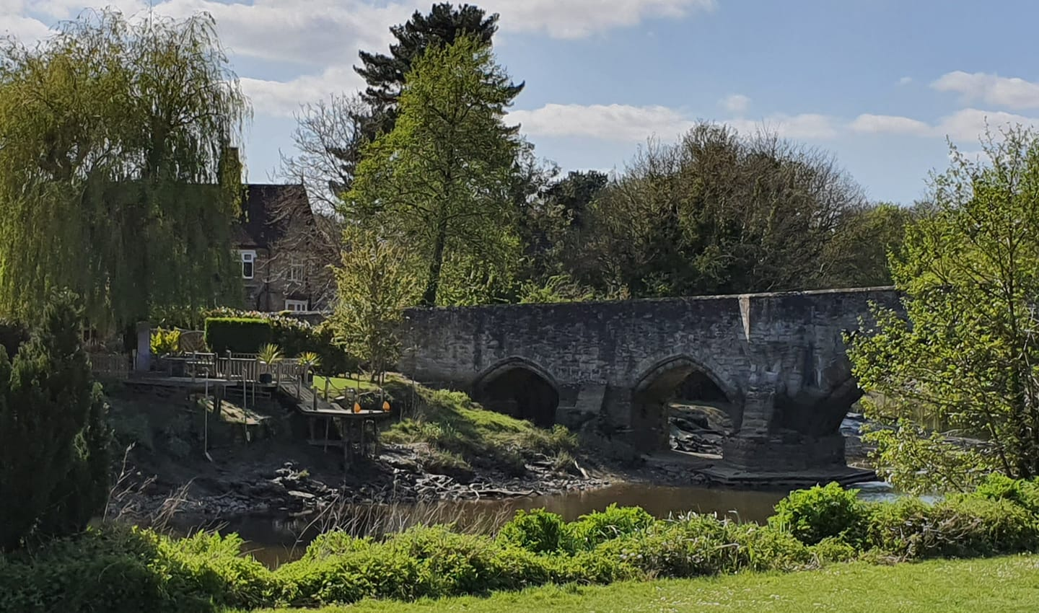

Cllr Andrew Kennedy's Newsletter
"On the side of the hardworking majority;
those who do what's right, play by the rules
and pay their fair share"
andrew.kennedy@kent.gov.uk
Tel: 07792 924820
Photo: Aylesford Bridge from Riverside Gardens
Photo credit: Andrew Kennedy

PLEASE SIGN MY PETITION TO RE-OPEN AYLESFORD TOWPATH

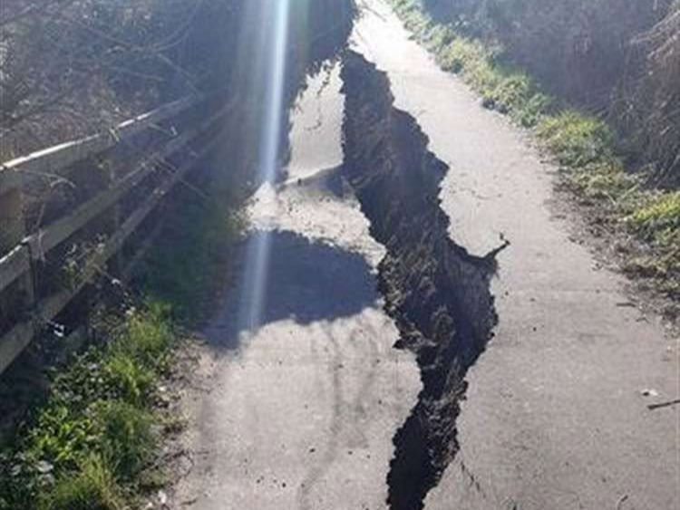

It is now six years since water erosion caused the land slip which led to the closure of the Aylesford Towpath, and two and a half years since Tracey Crouch, in one of her last major achievements as Chatham and Aylesford's MP, secured £1.2 million from the Government's Active Travel Scheme to finance the repair.
On 19 March 2025 the then KCC Cabinet Member for Highways, Neil Baker, published an "Executive Decision" instructing the reinstatement to go ahead, giving authority for the additional funding and resources to be made available to complete the project.
Since then, despite my best efforts and the very strong support of KCC's Public Right of Way Manager, little progress has been made.
This towpath was, and should once again be, a key feature for our community. It provided a safe walking route from Aylesford to Allington Lock and Maidstone, promoted better health from walking and cycling and helped people with poor mental health.
Despite regular requests from me for an explanation for the delay and repeated demands for work to commence, I have not received any satisfactory answers to explain or justify the lack of progress.
I am now seeking support from the community: 5,000 signatures will enable me to have this issue debated at a full meeting of Kent County Council when I can seek answers from the administration to explain the delay and a timeframe for work to commence.
Please sign the petition via the link below and share widely with your friends and neighbours encouraging them to sign too.
Thank you

CLICK HERE TO SIGN THE PETITION

A NEW VILLAGE SIGN FOR ECCLES

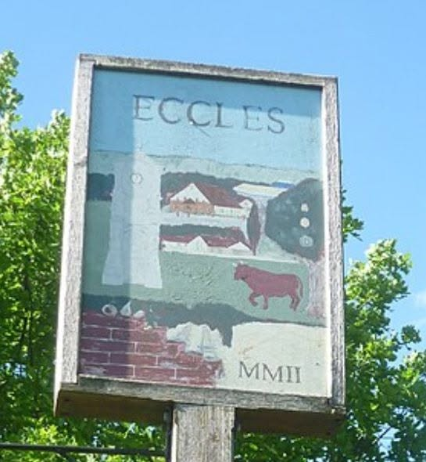

The Eccles Village sign was painted by local resident Roberta "Bobby" Francis in 2002.
After two decades of being battered by British weather and several attempts to clean it, it's now looking a bit worse for wear.
I was approached by a number of local residents to ask if it could be restored to its original condition and I found a well known and respected local artist, Stephen Moriarty from Wouldham, who was able and willing to do it.
Sadly Bobby Francis is no longer with us, but a few weeks ago I went to visit her husband Gordon at his home in Bull Lane. I explained what I was planning to do and secured his consent and approval. He was pleased that his wife's work of art was going to be restored for future generations.
The plan is to repair the wood and then repaint then sign "like for like" keeping the original design. It will then be weatherproofed to protect it for hopefully another 25 years.
The sign will be removed in the coming weeks for restoration and replaced in the autumn. I have invited Gordon to officially unveil the restoration in memory of Bobby. I hope when the time comes that many residents will join us .
The restoration will be funded by a grant of £750 from my KCC Community Fund with the balance being paid by Aylesford Parish Council.

STRAWBERRIES GALORE



This Friday 7 August almost 100 local residents have booked to attend my Strawberry Tea at Blue Bell Hill Village Hall.
Twelve kilos of Hugh Lowe Farm Strawberries (the same ones that are sold at Wimbledon) will be served alongside six litres of double cream, three litres of Rodda's Clotted Cream, one hundred scones and several hundred cups of tea!
My heartfelt thanks to all who have booked tickets and my amazing team of helpers who will assist with the setting-up of the hall, serving the food and washing-up afterwards, including Cllr Des Keers, Joyce Gadd, Debbie Rowe, Carol Park and Pauline Bowdery.
The ticket money and proceeds of the raffle will raise over £1,000. This will be used to help cover the costs of my annual Veterans' and Community Heroes' Christmas Carol Concert, now in its fourth year.
This year's event will be held on Wednesday 16 December 2026 in the Oaken Hall at Ditton Community Centre. Once again we will be entertained by the excellent West Malling Community Choir and the Chatham & Brompton Military Wives' Choir, under the musical direction of Kathryn Ridgeway.
If you know of a local military veteran, or anyone in your community who goes above and beyond the call of duty, who might like an invitation to attend my annual Carol Concert you are welcome to nominate them using the link below.

Click HERE to nominate a Veteran or Community Hero

NEW COUNCILS FOR KENT

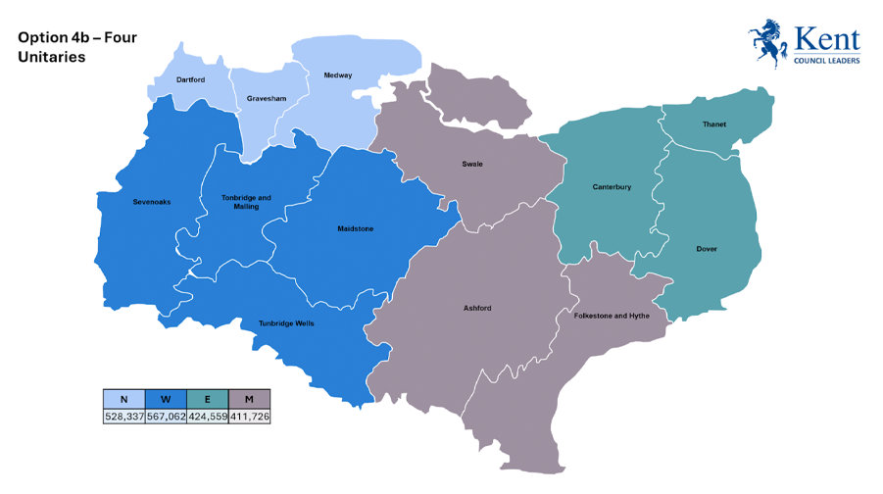

As you will probably be aware, the outcome of the Labour Government's reorganisation of Local Government in Kent has been published, and I fear it will be an expensive folly resulting in higher costs alongside bigger local councils, even more remote from the people they are elected to serve.
Originally I was supportive of local government reorganisation, but that was when we were looking at reorganisation and devolution resulting in an elected Mayor for Kent with extra funding and more decisions being made locally. But this was denied to the people of Kent without any explanation. Instead, we have this "pig's ear" with all the costs of reorganisation without any of the benefits of devolution. We will be paying higher Council Tax for years to come to finance this.
The entire County Council Division I represent (Malling North East) - including Ditton, Aylesford, Kits Coty, Burham, Eccles, Wouldham, Peters Village, Blue Bell Hill and Walderslade, will be transferred into the new West Kent Unitary Council. This will also include the rest of Tonbridge & Malling Council area along with Sevenoaks, Maidstone and Tunbridge Wells (the area shaded dark blue on the map above).
Three other unitary councils will also be created locally. These are North Kent (in light blue), Mid Kent (in grey) and East Kent (in green).
On Thursday 6 May 2027 there will be the first elections to the new West Kent Unitary Council. I have informed the Conservative Party that I would like to seek re-election as your local councillor and will, if approved, be seeking your continued support at next year's election.
For the first 12 months the new West Kent Unitary Council will run alongside both KCC and T&MBC. Over the course of that first year, control and management of local services will be transferred from the old councils to the new. Then in May 2028 T&MBC and KCC will be abolished and the new council will take over responsibility for local services.
I will write more about this in future newsletters, but I just wanted to bring you all up to date with what is happening and to let you know it is my intention to seek your support.

PLEASE CHIP-IN TO HELP GET ME RE-ELECTED



If any readers would like to purchase a raffle ticket (or two) to help support my 2027 re-election campaign, I would be very grateful.
Tickets are £2.50 each and the prizes are:
1. £500 cash
2. Fortnum & Mason Hamper
3. River Thames Afternoon Tea Cruise
4. Classic Car Driving Experience
5. Four x £50 Waitrose Gift cards.
If you would like to buy a raffle ticket and help me get re-elected at the 2027 election please click HERE to buy your raffle tickets online using PayPal.
Thank you.

REST IN PEACE, ANN

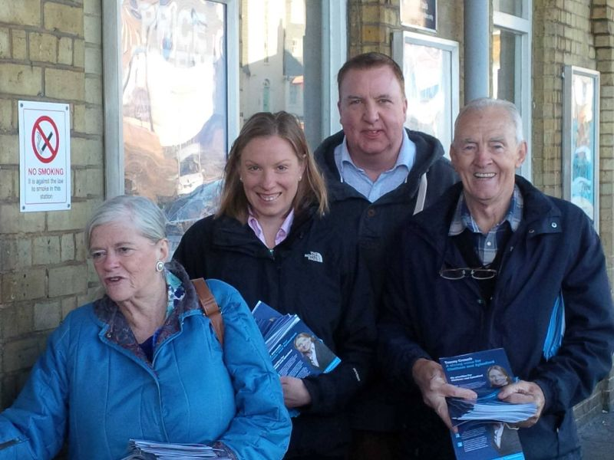
Ann Widdecombe with Tracey Crouch, me and Cllr Allan Sullivan campaigning at Chatham railway station at 7am during the 2015 General Election.

By the time you read this, the funeral of my friend, Ann Widdecombe, will have taken place at Buckfast Abbey in Devon.
A 78 year old lady savagely beaten to death by 21 hammer blows to her head, while she was sitting eating her lunch in the apparent safety of her home on the edge of Dartmoor.
Ann was my second friend in politics to be murdered.
The other was Sir David Amess, who at the time of his murder was the Member of Parliament for Southend West. He was stabbed to death at his weekly Advice Surgery. David was a kind, gentle and decent man - a devout Christian who had given a lifetime of service to the people of Southend.
Before that we had Jo Cox MP who was shot and stabbed to death on the street in the village of Birstall in Yorkshire, as she walked towards the local library to meet and help residents with their problems.
The trial of the man charged with Ann's murder has not yet been held, so it would be inappropriate to speculate. But in the cases of both David Amess and Jo Cox, the convicted murderers both said they were influenced by online 'hate speech'.
Everyone in politics, from all parties and at all levels, face this. Including me.
This week alone three different people have posted on social media that I am "corrupt" or that I "accept brown envelopes". In every case I challenge them to go to the police and present their evidence. They never do, as there is no evidence to present. But this doesn't stop them. Their comments are seldom challenged and almost never removed by the site administrators.
At the last election I know personally of over fifteen good local councillors who stepped down because of online abuse and the affect it had on them and their families. Likewise many MPs leave Parliament due to the abuse and the consequences on their children and loved ones
I guess 99.99% of people read this stuff, shrug and ignore it - but it has consequences. This was demonstrated to me when an elderly resident in one of the retirement homes in the Royal British Legion Village called me up to say how disappointed she was to read that I was taking backhanders. I assured her it was not true. "But I read it on the Aylesford Facebook Page, if it's not true, why don't you do something about it?"
And this is the problem.
If I published a newspaper article claiming that someone was a criminal without a shred of evidence, I would be sued for libel and the editor of the paper would be too. But people feel it's perfectly acceptable to publish such slander on a Facebook page read by tens of thousands of people and get aay with it. Those who manage those pages often turn a blind eye, claiming they are too busy to read all the comments (even when such comments are pointed out to them, they often remain on the page for all to read).
When people find it OK to call politicians corrupt, shout that they have "blood on their hands", accuse them of "destroying the environment for personal gain", call them evil - then the 99.99% who don't believe it are not the problem. It's the 0.01% who do believe it who we need to worry about - as this is the group who will decide they are doing society a favour when they stab and shoot.
And it's not just politicians who suffer. Too many young people commit suicide and turn to self harm due to online hate and bullying.
It is time the social media platforms and site administrators took responsibility for what is published on their platforms and those who publish hate speech and defamatory comments face legal consequences for their actions.



