

Cllr Andrew Kennedy's Newsletter
"On the side of the hardworking majority;
those who do what's right, play by the rules
and pay their fair share"
andrew.kennedy@kent.gov.uk
Tel: 07792 924820
Photo: Kits Coty House in the Spring Sunshine
Photo credit: Debbie Rowe, Blue Bell Hill

2,300 SIGNATURES AND COUNTING

A few weeks ago I invited local residents from Oaks Dene and Montfort Road in Walderslade to join me, Cllr Des Keers and members of Aylesford Parish Council, at the office of Helen Grant MP. We presented a petition of over 2,000 local residents opposing the housing of asylum seekers in residential properties.
Helen has been outstanding in her support for local communities and is asking questions in Parliament about this policy and lack of transparency.
I am not going to go through the entire issue again as I did so in my last newsletter (click HERE to read the full story) but the secrecy around this has been truly appalling.
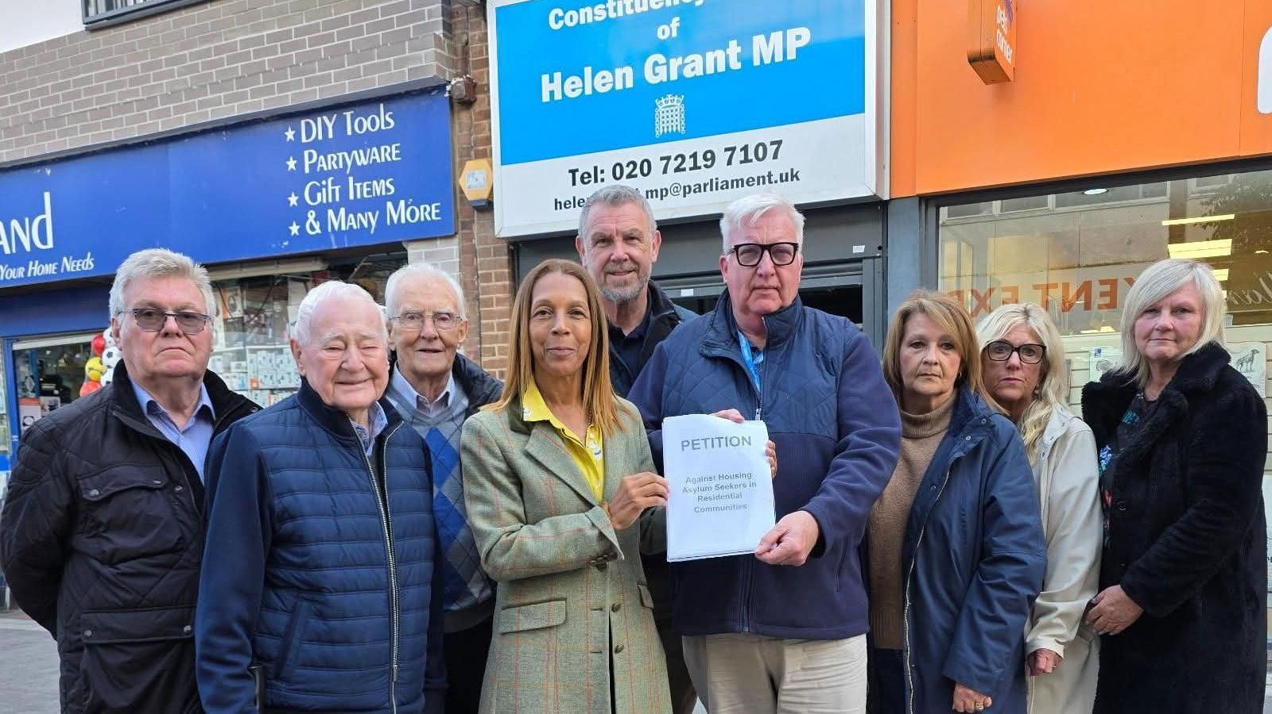

Had I not received a tip-off, gone to the press and told local people what was happening, the first residents would have known that properties in their road had been sold to house young male asylum seekers would have been the day they moved in.
I appreciate that not everyone shares my views on this. Some people take a more liberal approach, but even they must surely admit that the lack of public consultation and transparency has been shocking.
We are fortunate in the T&MBC area that both council leader Matt Boughton and local Walderslade councillor Des Keers have stood shoulder to shoulder with residents, though their power is limited as it's a government policy. Our Labour MP has been almost invisible.
Even now my colleagues in other Kent councils are been fobbed-off. Maidstone councillor, Stanley Forecast, who represents Allington and Palace Wood, has been asking for over a month if properties in his area will be used to house asylum seekers. The council is refusing to tell him. The same is being reported elsewhere.
From day one I have said, "the job of a local councillor is to represent the priorities of his/her community at the Town Hall, not to represent the priorities of the Town Hall in the community."
I stand by that 100%.
Local residents pay Council Tax which in turn pays for local services. Council Tax also pays the salaries of Council Officers and allowances paid to councillors. You are the customer, however inconvenient that might be to some. Public servants (whether officials or councillors) should represent the needs of their communities, not work hand in glove with the government and the Home Office to hide what's happening.

CASH FOR GOOD CAUSES



Each year I receive a small pot of money from Kent County Council which I can use to help and support local community groups and projects. Any group may apply, though I give priority to groups that help and support people with poor mental health, provide companionship and support for those dealing with loneliness and social isolation, support veterans or build confidence among younger people.
The money I receive from KCC is enhanced by an additional sum of money I contribute personally and through my own fundraising.
If you run a voluntary or community group and would like to apply for a grant of £250 - £500 please let me know. Your Group must have a proper written constitution and a bank account with two signatories. Also the money must be used for a specific project, not day-to-day running costs.
For example, last year I made the following donations: Ditton Scouts for new cooking equipment, Aylesford Scouts for campaign supplies, Blue Bell Hill Village Hall for new CCTV, Eccles Church towards the cost of Father Christmas' Grotto, Burham Parish Council for improvements to the War Memorial, Wouldham Guides and Brownies, Nexus School in Wouldham for a Sensory Garden, a new picnic bench for Tunbury Rec in Walderslade, St Peter and St Paul's Primary for new playground equipment, Aylesford Dementia Cafe, Aylesford Food Bank, Ditton Heritage Centre for new storage for their archives and much more.
Please email me at andrew.kennedy@kent.gov.uk with details of how much you would like and what it will be used for. I will let you know if I can help and if so I will send you an application form.

STANDING UP FOR RESIDENTS OF DITTON AND AYLESFORD OVER HGV MOVEMENTS

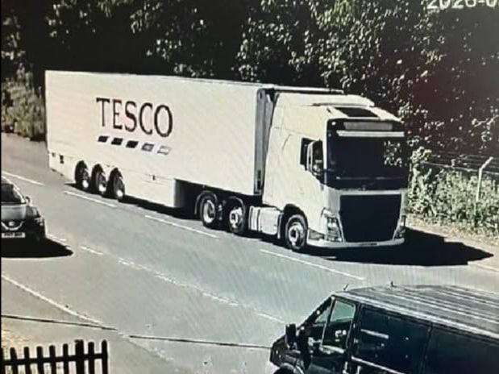
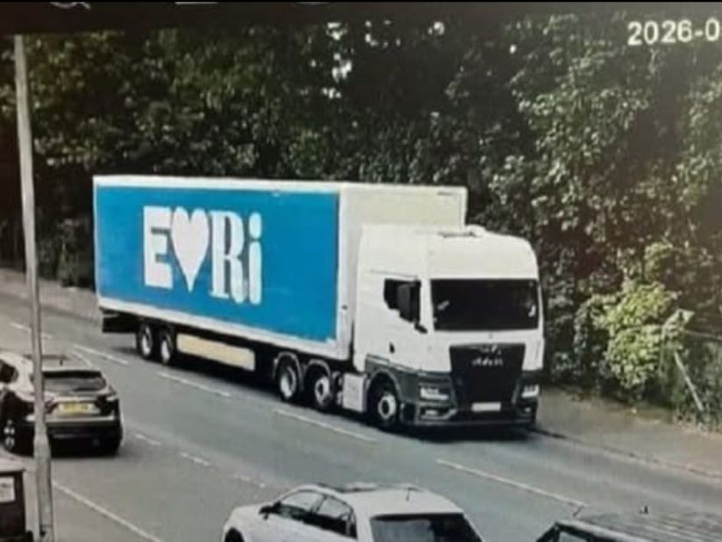

For the best part of a year I have been emailing the management team at Panattoni Park and individual hauliers / logistic companies requesting they instruct their drivers or contractors to respect the 7.5t weight limit. In the majority of cases I don't even receive a reply.
Just to clarify - I am talking about the 7.5t restriction on Bellingham Way just before the traffic lights onto Station Road. The Traffic Order is clear - this is not an "Except for Access" Order, it is No Vehicles over 7.5t Except Buses. It is a criminal offence for a driver of an HGV over this weight to turn left or right out of Bellingham Way.
This weight restriction is there for a good reason. Station Road and Hall Road already have poor air quality due to standing traffic when the crossing is closed. They are residential roads and a designated school route. I also have evidence that many HGV drivers are rat-running along Admiral Moore Drive (through the Royal British Legion Retirement Village) to avoid traffic at the Hall Road / A20 junction.
The designated route (Bellingham Way, Leybourne Way, Castle Way and M20 J4) was specified at the planning stage. Every logistics company was aware of this when they moved their operation to Panattoni Park. There is no excuse.
This is nothing to do with hostility to HGV drivers - we all appreciate their work and we rely on them for our food and produce deliveries. This is about the minority of HGV drivers who break the law, adding to pollution in our community as well as endangering residents.
Given their lack of response I have now started "naming and shaming" the companies on Twitter (X) and asking them to explain why their drivers are breaking the law. Tesco have already engaged positively, which indicates the tactic is working. It would of course be easier if companies instructed their drivers to obey the law, but sadly that has not always been the case.

PRAYERS AND PATRIOTISM

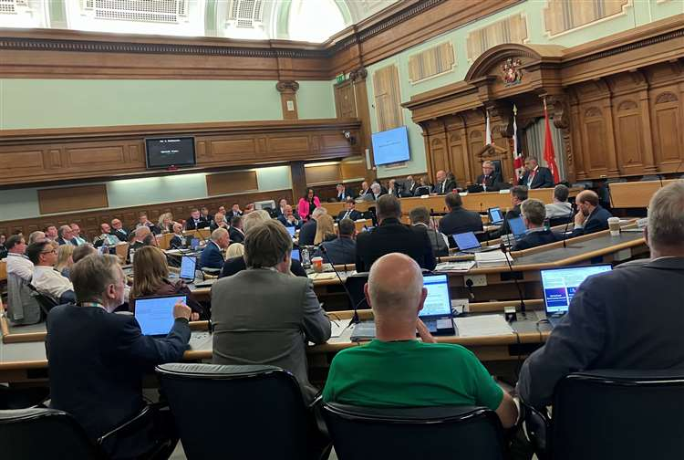

I hit the headlines again a few weeks ago when I joined Labour, Green and LibDem Councillors at Kent County Council to vote against proposals pushed through by the ReformUK-led council to introduce Christian prayer at the start of each council meeting and a patriotic singalong at the conclusion.
I have nothing against people who follow their faith even though I am agnostic. I am also proudly patriotic - if I am alone in my own home I will stand if the National Anthem is played on the TV. But these are personal matters and should have nothing to do with my work as a councillor.
If ReformUK had suggested to have prayers in the Chairman's Office before the meeting began, I would support it 100%. But to have this as part of official council business is hugely disrespectful to those like me who have no faith, or those who follow a different faith.
And to be blunt, to have ReformUK talk about the importance of Christan values when those very same people voted to remove funding for food stamps for the homeless and use the money to employ party political advisers is truly sickening.
This policy is nothing to do with delivering local services, tackling the £30 million black hole in Adult Social Care, improving the roads and highways, dealing with the massive backlog of Blue Badge applications or addressing the mess of SEND and the lack of local buses.
It is a stunt worthy of Donald Trump and the American Far-Right. It should have no place in British politics.

COULD YOU SPEAK-UP FOR YOUR COMMUNITY?

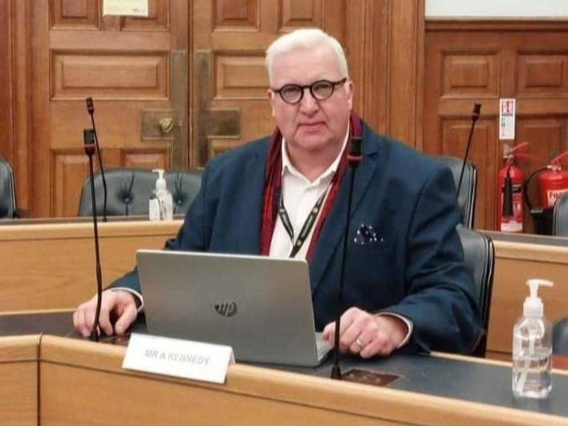

In May 2027 there will be elections for the new Unitary Councils being imposed on us by the government. There will also be elections for our four local Parish Councils (Aylesford, Burham, Ditton and Wouldham).
Being a local councillor can be very hard work - and often incredibly frustrating. But it also gives you a platform to campaign for your community and an opportunity to get things done. You do receive an allowance, but it's not a salary or a living wage! If I divide my monthly allowance by the hours I work, it falls far below the minimum wage. No-one does it for the money.
Parish Councillors however are all volunteers, but they still do important work locally. They look after village halls and community centres, parks and gardens, play areas and often sports grounds and have a role representing their community on planning matters.
If you would like to attend an informal discussion to find out more about the work of a local councillor, please click the link below and register your interest.

Express your interest in becoming a local councillor

KEEPING MY PROMISE FOR SEVEN CONSECUTIVE YEARS

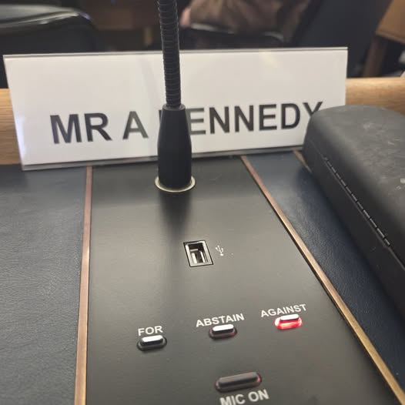

When you first elected me in 2019 I made a pledge that I would not vote for any councillor pay increase and I would not claim expenses. I have kept that promise ever since.
At the March meeting of KCC ReformUK proposed a councillors' pay rise of 3.8%, above the rate of inflation. I voted and spoke against that proposal.
Reform used their majority to push this through, so as in previous years I will be donating the increase to three local charities. This year I have nominated:
(a) Aylesford Food Bank at the Brassey Centre
(b) Maidstone Hospital League of Friends
(c) The retirement community at the Royal British Legion Village

SUPPORTING OUR COMMUNITY



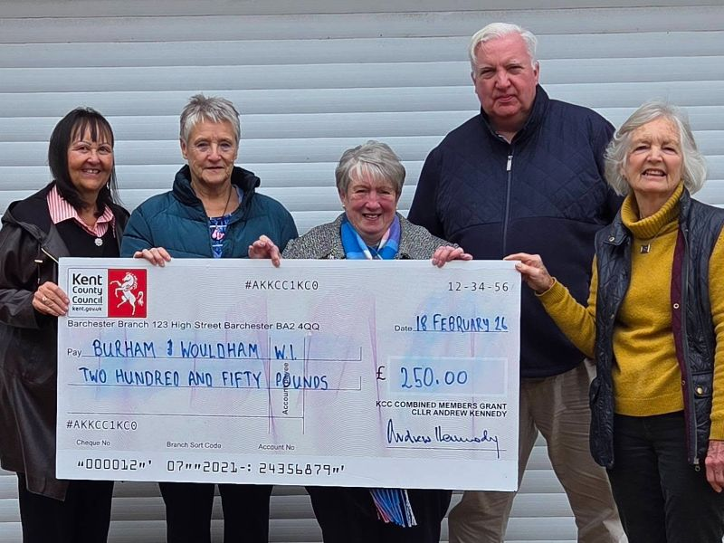



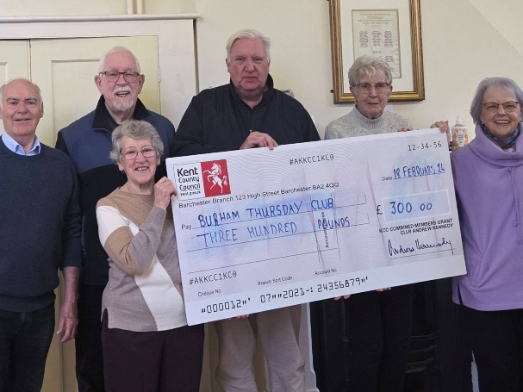

Finally, a pictorial round-up of some of the local voluntary groups I have been able to support recently with grants from my Community Fund. Thank you to all our local volunteers who do so much great work.



Copyright © 2026 Cllr Andrew Kennedy, All rights reserved.
You are receiving this email because you opted in via our website.
Our mailing address is:
Cllr Andrew Kennedy
Flat 5 Knowle House
34 Waterman Way, Wouldham
Rochester, Kent ME1 3FY
United Kingdom
Add us to your address book
Want to change how you receive these emails?
You can update your preferences or unsubscribe from this list.


