19 February 2026

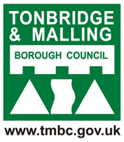 | Newsletter special  February 2026

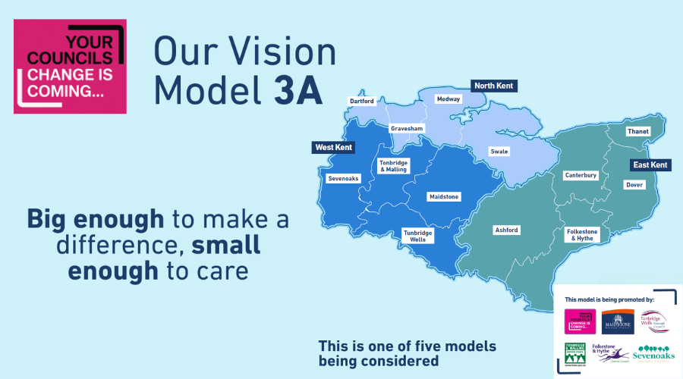

​ | Make your voice heard: The future of local councils  Residents, businesses and community organisations across Kent and Medway are invited to take part in an important consultation on the future of local councils.  The Government has launched the consultation as part of Local Government Reorganisation - the biggest proposed change to how councils are structured in around 50 years.  What is Local Government Reorganisation (LGR)?  At the moment, different councils are responsible for different services. For example, Kent County Council provides services such as education, social care and highways, while borough councils like Tonbridge and Malling deliver services including waste collections and recycling, planning, housing and leisure services.  Under the proposed changes, a smaller number of unitary councils would each deliver all local services within their area - bringing everything together in a simpler, more joined-up way.  Our preferred option  The consultation invites views on the five options for LGR that were submitted by councils across Kent and Medway before Christmas. This includes the three unitary option known as Model 3a, supported by the greatest number of councils, namely Tonbridge and Malling, Tunbridge Wells, Sevenoaks, Maidstone and Folkestone & Hythe councils.  Model 3a would see existing councils in Kent come together into three unitary areas, made up of Tonbridge and Malling, Sevenoaks, Maidstone and Tunbridge Wells in the west; Dartford, Gravesham, Medway and Swale in the north and Ashford, Canterbury, Thanet, Dover and Folkestone & Hythe in the east.  Big enough to make a difference, small enough to care  Looking at the evidence, it is clear that this model offers the best outcomes for local people in terms of:  - Respect for established identities  - High-quality, joined-up services that are accountable to local residents  - Better value for money  Some other models have been put forward for how councils in Kent could be organised in the future but these do not offer the same package of benefits. Government is consulting on all proposals before any decisions are made.  Why your voice matters  Your feedback will help Government understand what matters most to people locally.  Leader of Tonbridge and Malling Borough Council, Councillor Matt Boughton, says:  “This consultation is an important opportunity for you to help shape how local services are delivered for years to come. Option 3a has clear benefits over the other models proposed. Please do share your thoughts and have your say on how you want council services delivered in the future”  What happens next?  - February – March 2026: Consultation period  - Summer 2026: Government decision expected  - May 2027: Elections for new councils  - April 2028: New councils begin operating  The timeline below shows how the process will move forwards, ensuring local people have a say before any decisions are taken.  Have your say  We encourage everyone to spare a few minutes to take part in the consultation. By sharing your views, you will help shape the future of local services in Tonbridge and Malling.  The consultation is open now and closes on Thursday 26 March 2026.  Option 3A. Big enough to make a difference, small enough to care  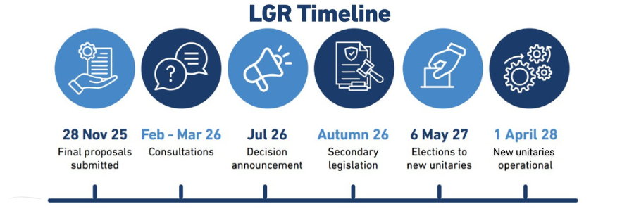  Have your say | ​

