

Cllr Andrew Kennedy's Newsletter
"On the side of the hardworking majority;
those who do what's right, play by the rules
and pay their fair share"
andrew.kennedy@kent.gov.uk
Tel: 07792 924820
Photo: Sunset over Ditton
Photo credit: Chezza Jarmyn

2025 CHRISTMAS CAROL CONCERT
Fast approaching!



Preparations are well underway for my fourth annual Carol Concert, which will be held this year on Wednesday 17 December 2025 in the Oaken Hall, Ditton Community Centre, Kiln Barn Road, Ditton ME20 6AH.
Doors will open at 6.30pm and the concert will commence promptly at 7.30pm. There is plenty of free parking on-site.
The concert is hosted by me and paid for by funds I raise from the generosity of the local businesses and individuals. The purpose of the concert is to bring together all the people who give their time and effort for the local community, as well as our many military veterans, to say thank you for what they do (or have done). There is no charge to attend.
This year we will be entertained by two choirs, who will sing a selection of modern and traditional Christmas music, including lots of 'audience participation'! The two choirs are the West Malling Community Choir, and the Chatham & Brompton Military Wives' Choir, both under the musical direction of the amazing Kathryn Ridgeway.
Guests will all receive a small Christmas gift from me, and there will be complimentary tea, coffee and fruit juice at the interval, along with mince pies, Christmas cake and satsumas.
Many people who receive this newsletter have probably already been invited, but if you have not received an invitation and would like to attend, I will do my best to fit you in. Please click the red the button below to register for a ticket. If there are more requests than we have space I will pick names from a hat.
If you have a friend or neighbour who is a military veteran, or who works hard for the community, then you are very welcome to nominate them to attend. To do this please click the dark blue button below.
I look forward to seeing many of you there on Wednesday 17 December.

Click HERE to book a ticket for my 2025 Carol Concert

Click HERE to nominate a Military Veteran or Community Hero

GRANTS FOR GOOD CAUSES

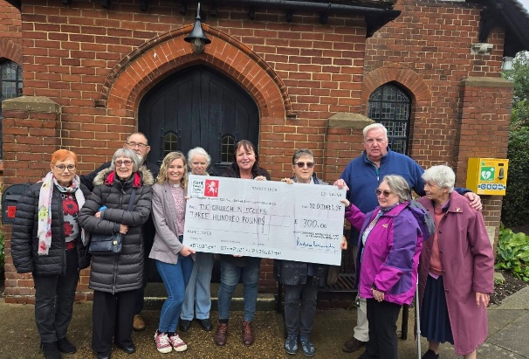
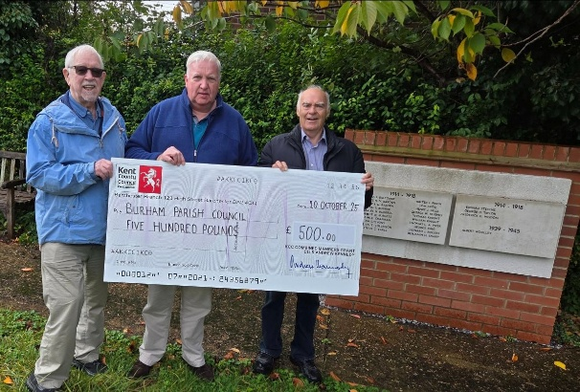

In recent weeks I have been delighted to support two great causes:
Above left: A few weeks ago I received a call from Father Christmas. Apparently he has accepted an invitation to visit Eccles to meet local children, but he needed some funds to buy them all a present and to decorate his grotto.
I was very pleased to help and I popped along to The Church in Eccles to meet the volunteers and to give them a donation of £300 to cover all the costs of Santa's visit.
If any local children would like to meet Santa in his grotto, their parent/guardian needs to complete a form which can be obtained from Aaron at the Village Shop, the Church or the pre-school.
Above right: I had the great honour of visiting the Burham War Memorial to see the new stones installed, listing the names of 23 more local men who died during the First World War, and one additional name of a local man who died during the Second World War.
These additional names were discovered due to the diligent work of the village historian, Michael Boozer.
I was pleased to present the Parish Council Chairman, Cllr David Young, and the Vice Chairman, Cllr Bill Stead with a cheque for £500 towards the cost of the new stones.



I still have a small amount of grant funding available for local voluntary groups.
I try to be fair and allocate my donations pro-rata to the population of each village, so (for example) a village with 15% of the population of my area will get 15% of the available funding. It doesn't always work out like that, as sometimes I simply do not receive many requests from certain areas. However, on this basis, I would particularly welcome applications from Blue Bell Hill and Eccles - but if you live elsewhere it's worth you asking!
As a rule I give preferences to the following types of groups:
- Groups aimed at supporting those who are isolated or lonely, or dealing with bereavement
- Youth groups including scouts, cubs, guides and brownies and groups providing sport for younger people
- Groups supporting those living with poor mental health or with dementia or Alzheimer's - and those who care for them
- Veterans
- Groups that strengthen community resilience or bring people together in friendship
There are some rules imposed by Kent County Council which applicants must meet:
- The grant (max £300) must be for local community based groups within Aylesford, Burham, Blue Bell Hill, Ditton, Eccles, Kits Coty, Peters Village, Walderslade or Wouldham. The people who benefit from the grant must also be mainly resident in the same villages
- The organisation applying must be volunteer-led and must not undertake any commercial profitable activities
- The group must have a written constitution and a bank account with two signatories
- The grant must be used for a specific project or activity and not to pay wages or routine running costs
If you run a community group and would like to apply for a grant, please email me at andrew.kennedy@kent.gov.uk and tell me about your group, what you do locally and what you want to do with the funding.

24 HOUR ONE-STOP OFF LICENCE IN NEW ROAD, DITTON

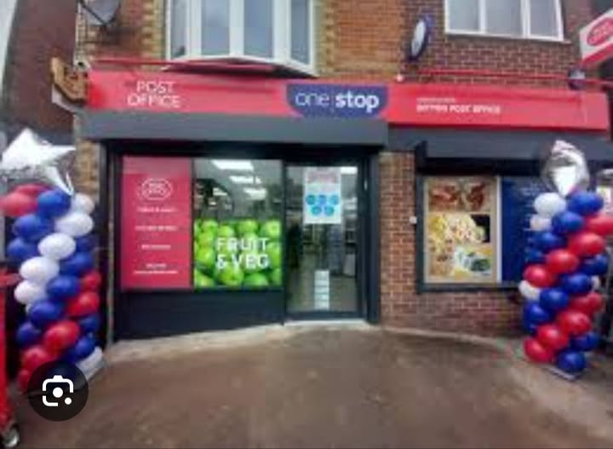

Over the summer months I joined forces with local residents and Ditton Parish Council to try and stop the application for a 24 hour license for the One Stop shop in New Road, Ditton.
I am sorry to report that despite our best efforts we were not successful.
We made the case against very strongly based on licensing law;
(a) Increased nuisance to local residents
(b) Likely rise in anti-social behaviour
(c) Likely increase in vandalism and litter
The panel of three councillors took an hour to reach their decision, so I am confident they gave our arguments very careful consideration.
I was however told by the Chair that whilst our concerns about noise, ASB and public nuisance were all valid, they were undermined by the fact that neither Kent Police or Environmental Health had raised no objection. Quite how Kent Police can think opening a 24 hour off-license in a residential area will not cause problems for the local community totally beggars belief. I will be raising this issue personally with Kent's Police and Crime Commissioner Matthew Scott.
All is not lost.
We can ask TMBC for a review in a few months if we see evidence of an increase in crime or ASB linked to the granting of the licence. Once the 24 hour opening is up and running I would like nearby residents to keep a diary of noise and disturbance. Also any examples of drunken behaviour should be reported to Kent police on 102 so there is an evidence trail. Please do this, moaning on Facebook is not 'evidence' !
I am sorry we could not stop this, we did our best.

THE OPENING OF THE ALLINGTON TIP
RE-USE AND RECYCLE SHOP

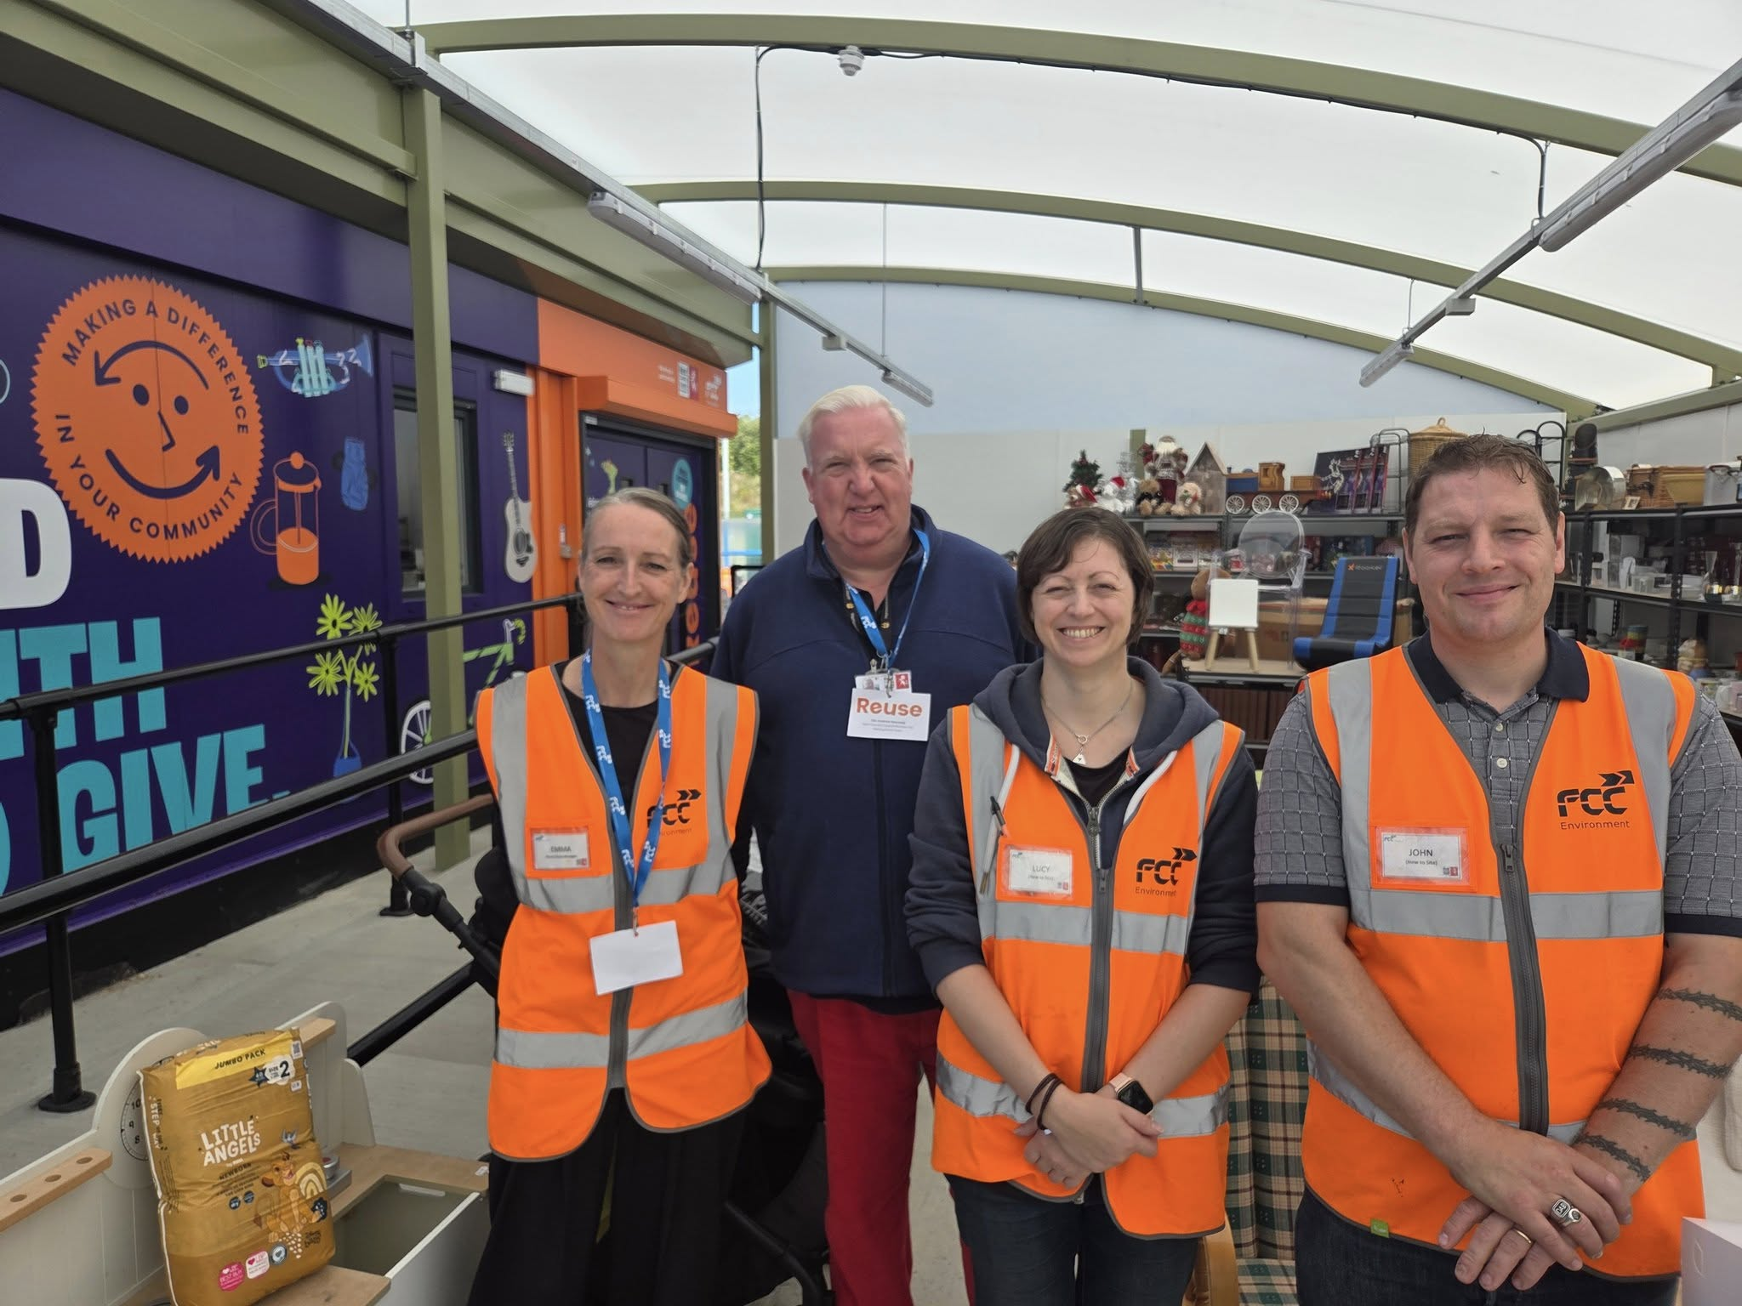

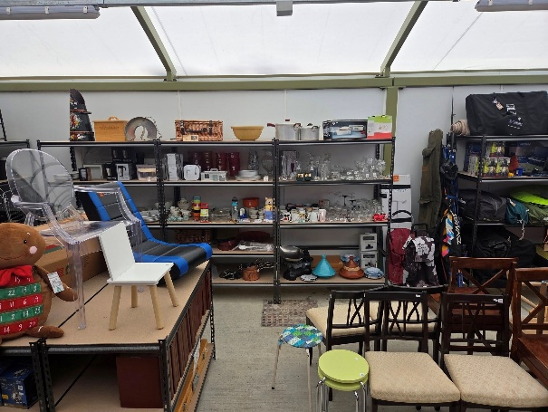
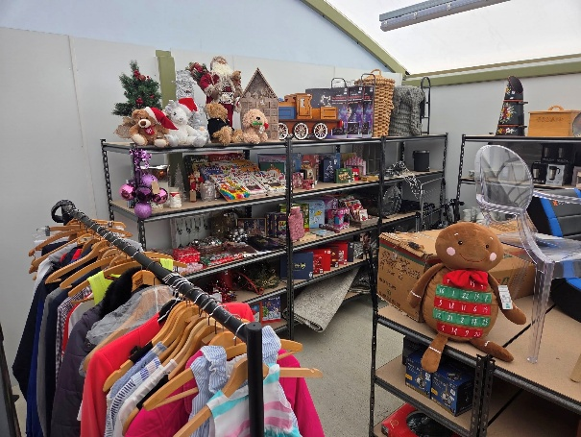

In September I was really pleased to attend the official opening of the Re-use and Recycle Shop located at Allington Household Waste Recycling Centre (HWRC).
I suggested this three years ago and it has finally come to fruition.
There is now a purpose-built shop on the site with a shop manager, Emma.
Residents can take along unwanted household goods for sale, with the money raised going to good causes.
Also the site staff who supervise the skips will be keeping an eye open for merchandise-quality goods being thrown away. If they spot something sellable they will ask the owner if they are happy for it to go into the shop. There is no obligation to say yes, and nothing will be pulled out of the skips for sale, but obviously the more that can be recycled the better as this will save £126 per ton in landfill tax.
The shop will be open 7 days a week from 8am to 4pm. If you want to visit to view or buy what's available you can just turn up. No need to book, however you do need to book if you are donating goods.
The shop was packed with really good quality stock: tools, kitchen equipment, furniture, electrical goods (all PAC tested on site), toys and games. Goods can be paid for by credit/debit card only - no cash!
I was pleased to meet the shop manager Emma and her assistants Lucy and John.
Please pop along and support this great initiative.
1. It will give a new lease of life to goods which are 'too good to go'
2. It will help people on low incomes or those setting up their first home to purchase items at a fraction of High Street prices, and
3. It will reduce waste and landfill tax.
What's not to like?

LIES, DAMNED LIES AND STATISTICS

As a rule I don't do "party politics" in my newsletter, but I am so angry at the propaganda from Kent's Reform-controlled council, I feel compelled to call it out.
ReformUK won the Kent County Counvol elections in May on a platform of cutting out "Tory waste" and using the savings to reduce your Council Tax.
Well, guess what?
Despite the high profile visit of Nigel Farage's "Department of Local Government Efficiency" (DOLGE) nothing has been cut and no savings found.
A senior Reform KCC Cabinet Member has said "we are down to the bare bones, there is nothing left to cut"
And the Financial Times has reported that we are likely to face a 5% Council Tax rise in April next year.
What has really made my blood boil however is a statement from ReformUK in Kent, bragging about their savings; none of which are accurate and most downright fictitious. If you are interested the button below highlights Reform's claims and the truth about Kent's finances.
Added to this is their absolute ineptitude at running the council. In just six months almost 15% of their councillors have been sacked or suspended.
- Maxine Fothergill (Sevenoaks Rural North East) suspended for bringing ReformUK into disrepute)
- Amelia Randall (Birchington) defected to UKIP
- Paul Thomas (Maidstone South): suspended for bringing ReformUK into disrepute
- Daniel Taylor (Cliftonville) suspended following police charges for repeatedly or continuously engaging in behaviour which was controlling or coercive towards his wife
- Bill Barrett (Ashford Rural South): suspended for bringing ReformUK into disrepute
- Robert Ford (Maidstone Rural West) suspended after accusations of making inappropriate and lewd comments to female KCC workers
- Oliver Bradshaw (Maidstone Central) suspended for bringing ReformUK into disrepute.
Then, of course, the indignity of seeing Kent CC Leader Linden Kemkaren bullying and cussing on a leaked video!
I genuinely understand why so many people felt let down by the Conservatives after 14 years of government, and I feel very fortunate to have held my seat in the face of Reform's landslide in Kent. But equally, I fear Reform are already falling apart and we are only six months in to their four year term.

The truth about Reform's so called savings at KCC



Copyright © 2025 Cllr Andrew Kennedy, All rights reserved.
You are receiving this email because you opted in via our website.
Our mailing address is:
Cllr Andrew Kennedy
Flat 5 Knowle House
34 Waterman Way, Wouldham
Rochester, Kent ME1 3FY
United Kingdom
Add us to your address book
Want to change how you receive these emails?
You can update your preferences or unsubscribe from this list.


